# **Project 01**

# **Project Steps**

## **1. Setup Minikube and Git Repository**

Start Minikube:

minikube start

1.2 Set Up Git Repository Create a new directory for your project:

mkdir nodejs-k8s-project

cd nodejs-k8s-project

Initialize Git repository:

git init

Create a .gitignore file:

node_modules/

.env

nano .gitignore

# Ignore node_modules directory

node_modules/

# Ignore environment variables file

.env

OR

echo -e "node_modules/\n.env" > .gitignore

Add and commit initial changes:

git add .

git commit -m "Initial commit"

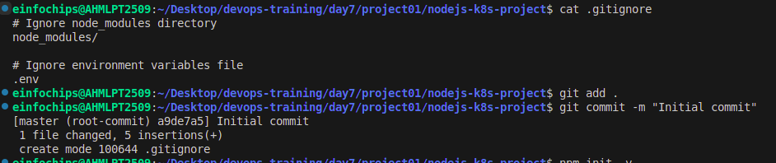

### **2. Develop a Node.js Application**

2.1 Create the Node.js App Initialize the Node.js project:

Initialize the Node.js project:

npm init –y

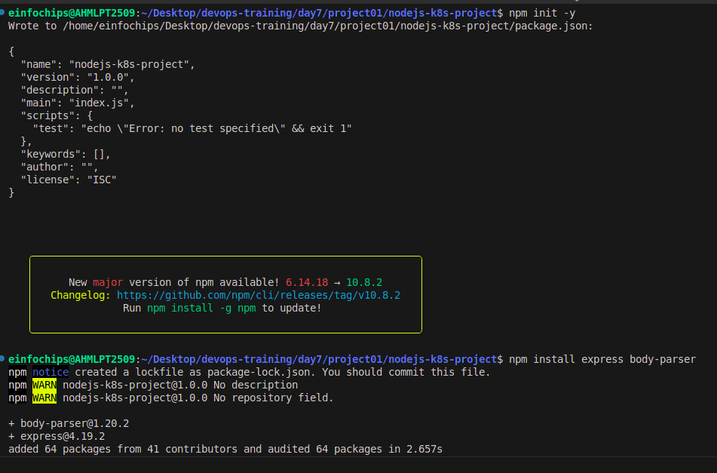

Install necessary packages:

npm install express body-parser

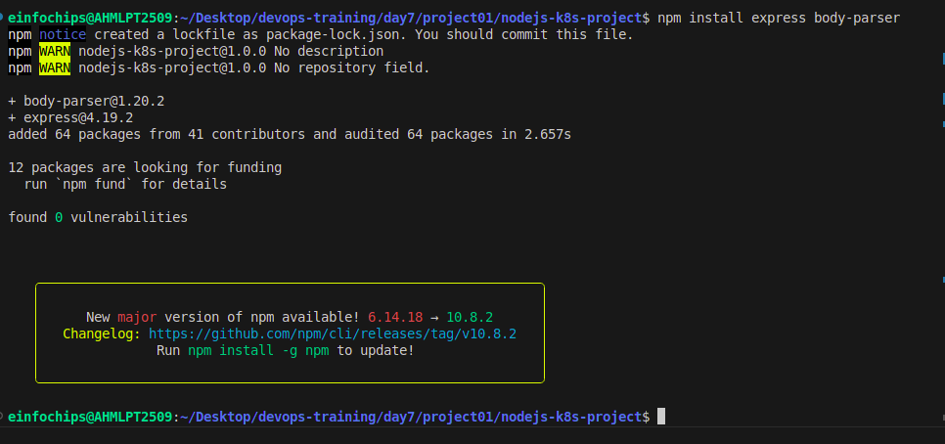

Create app.js:

nano app.js

const express = require('express');

const bodyParser = require('body-parser');

const app = express();

const PORT = process.env.PORT || 3000;

app.use(bodyParser.json());

app.get('/', (req, res) => {

res.send('Hello, World!');

});

app.listen(PORT, () => {

console.log(`Server is running on port ${PORT}`);

});

Update package.json to include a start script:

"scripts": {

"start": "node app.js"

}

**Update package.json** to include a start script:

nano pacakage.json  
  
"scripts": {

"start": "node app.js"

}

2.2 Commit the Node.js Application Add and commit changes:

git add .

git commit -m "Add Node.js application code"

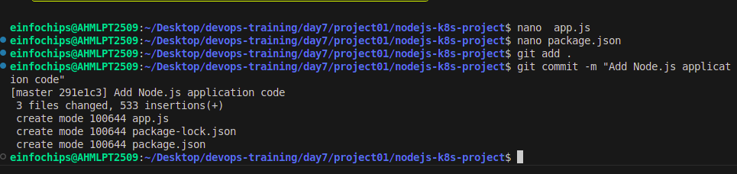

### **3. Create Dockerfile and Docker Compose**

3.1 Create a Dockerfile Add Dockerfile:

### **Use official Node.js image**

#### nano Dockerfile

FROM node:18

# Set the working directory

WORKDIR /usr/src/app

# Copy package.json and package-lock.json

COPY package*.json ./

# Install dependencies

RUN npm install

# Copy the rest of the application code

COPY . .

# Expose the port on which the app runs

EXPOSE 3000

# Command to run the application

CMD [ "npm", "start" ]

Create a .dockerignore file:

nano .dockerignore

node_modules

.npm

**OR**

echo -e "node_modules\n.npm" > .dockerignore

3.2 Create docker-compose.yml (optional for local testing) Add docker-compose.yml:

**docker-compose.yml**

version: '3'

services:

app:

build: .

ports:

- "3000:3000"

Add and commit changes:

git add Dockerfile docker-compose.yml

git commit -m "Add Dockerfile and Docker Compose configuration"

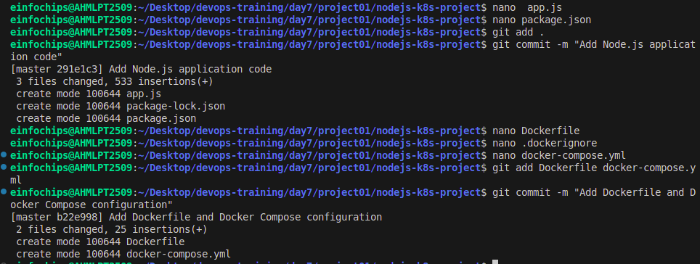

### **4. Build and Push Docker Image**

4.1 Build Docker Image Build the Docker image:

docker build -t nodejs-app:latest .

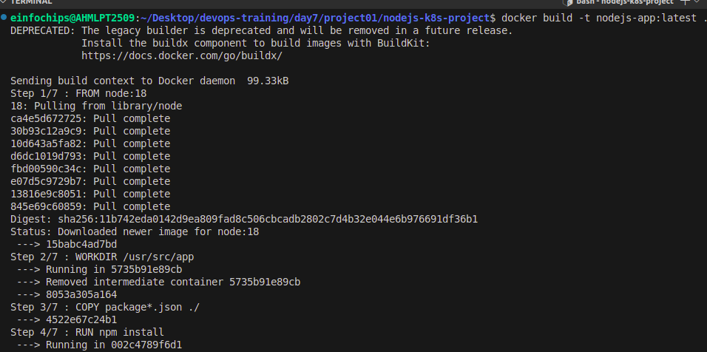

4.2 Push Docker Image to Docker Hub Tag and push the image:

docker images

docker tag nodejs-app:latest shital37/nodejs-app:latest

docker push shital37/nodejs-app:latest

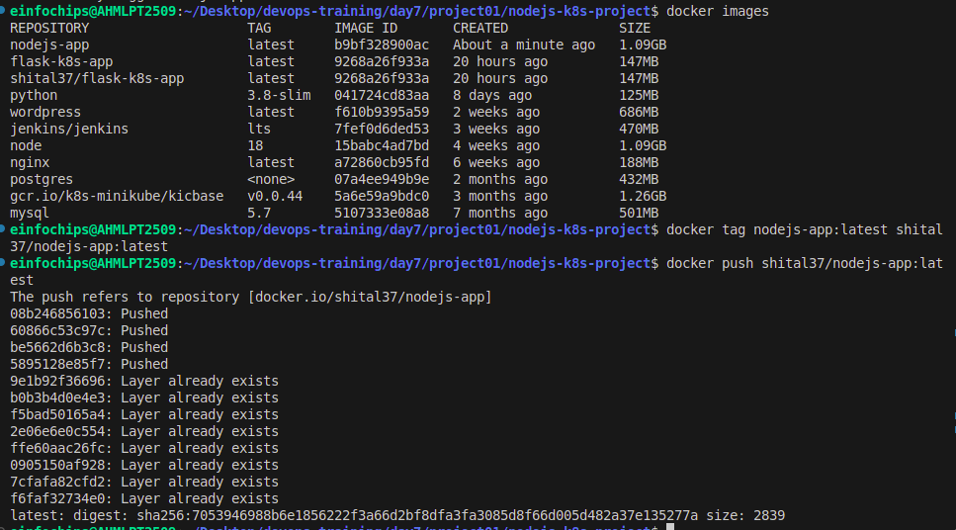

Add and commit changes:

git add .

git commit -m "Build and push Docker image"

### **5. Create Kubernetes Configurations**

mkdir kubernetes

5.1 Create Kubernetes Deployment Create kubernetes/deployment.yaml:

nano kubernetes/deployment.yaml

apiVersion: apps/v1

kind: Deployment

metadata:

name: nodejs-app-deployment

spec:

replicas: 2

selector:

matchLabels:

app: nodejs-app

template:

metadata:

labels:

app: nodejs-app

spec:

containers:

- name: nodejs-app

image: shital37/nodejs-app:latest

ports:

- containerPort: 3000

env:

- name: PORT

valueFrom:

configMapKeyRef:

name: app-config

key: PORT

- name: NODE_ENV

valueFrom:

secretKeyRef:

name: app-secrets

key: NODE_ENV

5.2 Create ConfigMap and Secret Create kubernetes/configmap.yaml:

nano kubernetes/configmap.yaml

apiVersion: v1

kind: ConfigMap

metadata:

name: app-config

data:

PORT: "3000"

Create kubernetes/secret.yaml:

nano kubernetes/secret.yaml

apiVersion: v1

kind: Secret

metadata:

name: app-secrets

type: Opaque

data:

NODE_ENV: cHJvZHVjdGlvbmFs # Base64 encoded value for "production"

Add and commit Kubernetes configurations:

git add kubernetes/

git commit -m "Add Kubernetes deployment, configmap, and secret"

5.3 Apply Kubernetes Configurations Apply the ConfigMap and Secret:

kubectl apply -f kubernetes/configmap.yaml

kubectl apply -f kubernetes/secret.yaml

Apply the Deployment:

kubectl apply -f kubernetes/deployment.yaml

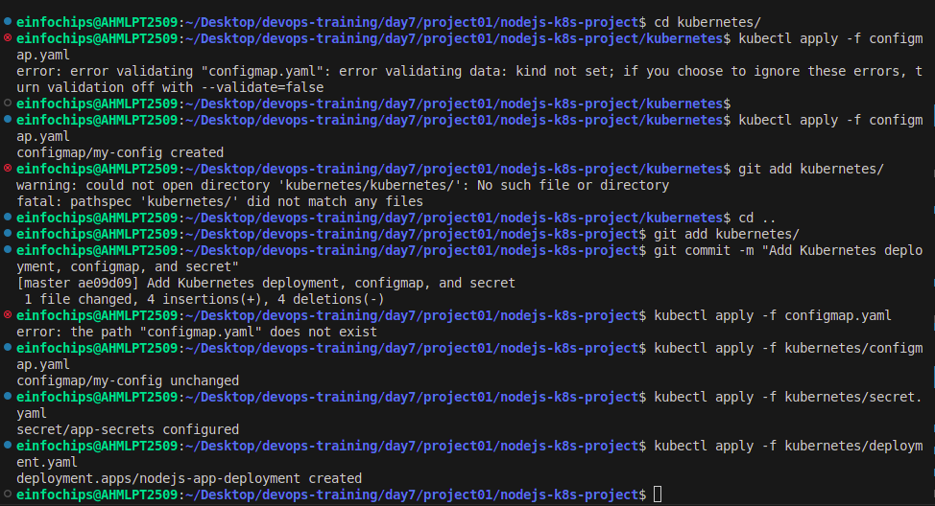

### **6. Implement Autoscaling**

6.1 Create Horizontal Pod Autoscaler Create kubernetes/hpa.yaml:

nano kubernetes/hpa.yaml

apiVersion: autoscaling/v2

kind: HorizontalPodAutoscaler

metadata:

name: nodejs-app-hpa

spec:

scaleTargetRef:

apiVersion: apps/v1

kind: Deployment

name: nodejs-app

minReplicas: 1

maxReplicas: 10

metrics:

- type: Resource

resource:

name: cpu

target:

type: Utilization

averageUtilization: 50

Apply the HPA:

kubectl apply -f kubernetes/hpa.yaml

6.2 Create Vertical Pod Autoscaler Create kubernetes/vpa.yaml:

nano kubernetes/vpa.yaml

apiVersion: autoscaling.k8s.io/v1beta2

kind: VerticalPodAutoscaler

metadata:

name: nodejs-app-vpa

spec:

targetRef:

apiVersion: apps/v1

kind: Deployment

name: nodejs-app-deployment

updatePolicy:

updateMode: "Auto"

Apply the VPA:

kubectl apply -f kubernetes/vpa.yaml

### **7. Test the Deployment**

7.1 Check the Status of Pods, Services, and HPA Verify the Pods:

kubectl get pods

Verify the Services:

kubectl get svc

Verify the HPA:

kubectl get hpa

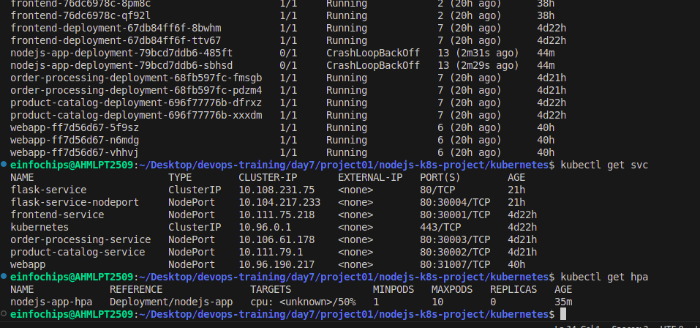

7.2 Access the Application Expose the Service:

kubectl expose deployment nodejs-app-deployment --type=NodePort --name=nodejs-app-service

Get the Minikube IP and Service Port:

minikube service nodejs-app-service --url

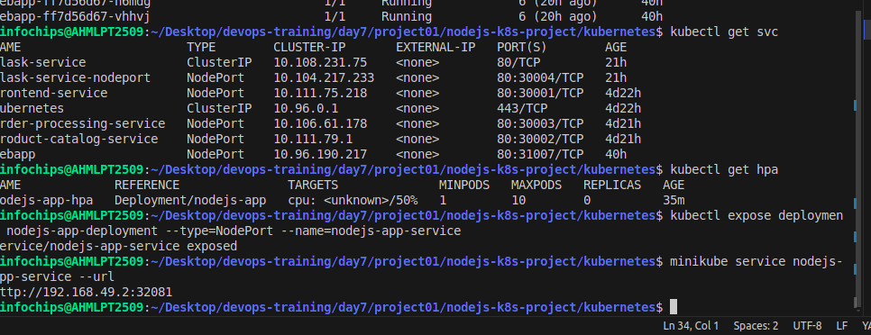

Access the Application in your browser using the URL obtained from the previous command.

### **8. Git Version Control**

8.1 Create a New Branch for New Features Create and switch to a new branch:

git remote –v

git remote add origin https://github.com/cshital/repository.git

git remote -v

git checkout -b feature/new-feature

git checkout feature/new-feature

Make changes and commit:

### **Make some changes**

git add .

git commit -m "Add new feature"

Push the branch to the remote repository:

git push origin feature/new-feature

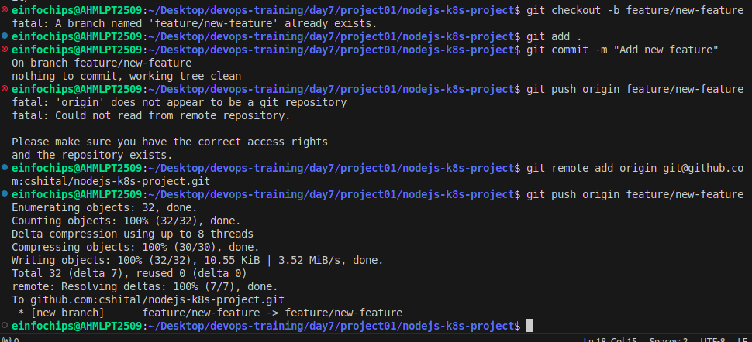

8.2 Rebase Feature Branch on Main Branch Switch to the main branch and pull the latest changes:

git branch -a

git checkout master

git checkout -b main

git checkout main

git pull origin main

Rebase the feature branch:

git checkout feature/new-feature

git rebase main

Resolve conflicts if any, and continue the rebase:

git add .

git rebase –continue

Push the rebased feature branch:

git push origin feature/new-feature –force

### **9. Final Commit and Cleanup**

Merge feature branch to main:

git checkout main

git merge feature/new-feature

Push the changes to the main branch:

git push origin main

Clean up:

git branch -d feature/new-feature

git push origin --delete feature/new-feature

